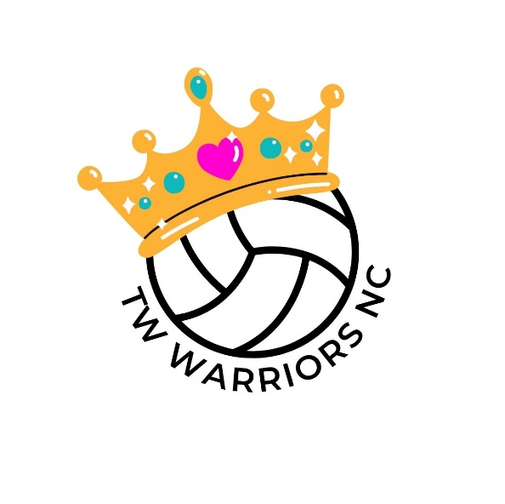

TW Warriors NC Privacy Notice
This Privacy Notice sets out how we use and look after the personal information we collect from you. We are the data controller, responsible for the processing of any personal data you give us. We take reasonable care to keep your information secure and to prevent any unauthorised access to or use of your personal data.
Personal Data
An individual’s confidentiality is protected by the Data Protection Act and, from 25th May 2018, the General Data Protection Regulation (GDPR) (Regulation (EU) 2016/679) and the Privacy and Electronic Communications Regulations 2016 (PECR).
What personal data we hold on you?
Personal data means any information about an individual from which that individual can be identified. We collect, use, store and transfer some personal data of our participants. You provide information about yourself and your members when you register with the club, and by filling in forms at an event or online, or by corresponding with us by phone, e-mail or otherwise. The information you give us may include name, date of birth, address, e-mail address and phone number. Where we need to collect personal data to fulfil club responsibilities and you do not provide that data, we may not be able to honour or administer your registration.
Why we need your personal data
We will only use personal data for any purpose for which it has been specifically provided. The reason we need participants’ and members’ personal data is to be able to run the netball club and arrange matches, to administer registrations, communicate club minutes and provide club services. Our lawful basis for processing this personal data is that we have a contractual obligation to anyone as a participant or member to provide the services they are registering for. The table below sets out all the ways we plan to use personal data. We have also identified what our legitimate interests are where appropriate.
Performance of a contract
Organising matches Performance of a contract
Sending out club information and updates Performance of a contract

Purpose/ Processing Activity | Lawful Basis for processing under Article 6 of the GDPR.
Processing registration forms | Performance of a contract
Communicate club minutes | Performance of a contract
Sending out club information and updates | Performance of a contract
Organising matches | Performance of a contract
Compliance with criteria to participate in the Tunbridge Wells Netball League | Performance of a contract
Sharing data with the club you are a member of League, County Netball associations and England Netball | Performance of a contract
Sharing data with committee members to provide information about league activities, registration renewals or invitations to social events | The club has a legitimate interest to maintain participant correspondence for club community purposes.
Sharing data with third party service or facility providers. | The club has a legitimate interest to run the organisation efficiently and as it sees fit. Provision of some third party services is for the benefit of the club and participants.
Sharing anonymised data with a funding partner as condition of grant funding e.g. Local Authority | The club has a legitimate interest to run the organisation efficiently and as it sees fit. Provision of some third party services is for the benefit of the club and participants.
Publishing match and league results | Consent. We will only publish personal data in a public domain, including images and names, if we have your consent for us to do so
Sending out marketing information such as upcoming tournaments, charitable events | Consent. We will only send direct marketing if you are an existing member, participant or other associated individual and you have not previously objected to this marketing, or, you have actively provided your consent.
To ensure we understand possible health risks | Consent. We will only process details on medical history with their consent.

Who we share your personal data with
When you register with the club, your information, if you are a player, umpire or club administrator will be entered onto word or excel databases which are administered by the Secretary or other Committee members. We may also pass your information to the League, County or EN for affiliation purposes, centralised administration purposes or disciplinary purposes. The club will allow members’ information to be used only by others working on their behalf and as required by law. The club will not share members’ information with other companies or charities for marketing purposes. The club has Facebook and Instagram accounts, members who engage with these social media accounts will have signed up under the privacy policies of the individual companies.
Protection of your personal data
We have put in place reasonable security measures, as a volunteer run organisation to prevent personal data from being accidentally lost, used or accessed in an unauthorised way, altered or disclosed.
How long we hold your personal data
We keep personal data on our participants while they continue to be a participant or are otherwise actively involved with the club in the current season. We will delete this data after a participant has left or otherwise ended their registration or affiliation, or sooner if specifically requested and we are able to do so during the season. All data is deleted prior to the start of the new season. The personal data that is stored on England Netballs affiliation data base is subject to ENs privacy policy so we advise you review that policy together with this notice.
Your rights regarding your personal data
You have a right at any time to request access to, rectification or erasure of their personal data; to restrict or object to certain kinds of processing of their personal data, including direct marketing.
Website
The club uses cookies on its website and the same privacy protection outlined above applies to the website. Cookies are used to store one’s session data, with details such as username to identify a user session. These cookies are set to expire after a pre-determined time and are not maintained. Members can accept or decline cookies by changing the settings in their internet browser. If cookies are disabled, some features of the website may be affected. For further information on how to disable cookies, please see this external third party website: www.allaboutcookies.org/manage-cookies.
Data transmission over the internet is inherently insecure, and the club cannot guarantee the security of data. The website contains links to other websites. The club are not responsible for the privacy policies or practices of third party websites. When members visit the club website, certain information is collected that does not identify them personally, but provides the club with "usage data" such as the number of visitors or what pages are visited most often. These data help to analyse and improve the usefulness of the information provided on the website.
Payments by Members
Payment made by Member Clubs, whether by cheque or online, are paid into
the club account and no details of individuals bank details are recorded. We may update this Privacy Notice from time to time, and will inform you of any changes in how we handle personal data. If participants have any questions about this Privacy Notice then please contact the club on twwarriorsnc@gmail.com

